USE OF THE LANGUAGE

1. Look at the sentences. Underline the adverbs frequency and explain the tense in which they can be used
2. The food always tastes delicious.
3. It is usually popular with families
4. Some of his friends never eat meat.
5. The Atrium is rarely quiet
6. Match these questions (1-4) with the answers (A-D) below
7. What is Annie doing?
8. What does Annie do?
9. When does Annie get up?
10. Where is Annie staying?
11. She gets up at 7:30
12. She’s listening to music
13. She’s staying with her sister
14. *We use the present simple for habits or regular events, often with frequency adverbs *
15. *We use the present simple for permanent situations *
16. *We use the present continuous for the present moment. *
17. *We use the present continuous for temporary situations. *
18. She works in a shop

Now match one rule with each answer above

1. Read this conversation. Put the verbs in brackets into the correct form of the present simple or the present continuous.

Ben: Hi Tom. I’m bored. I _______ (sit) in my room and there’s nothing to do. What _______ (you/do)?

Tom: I ________ (look) after my little brother. My mum’s got a new job and she _______ (work) on Saturdays.

Ben: __________ (you/look) after him every Saturday?

Tom: No, my mum usually ___________ (take) him to my grandparents but they _____ (play) golf today.

Ben: Oh. Well. I _______ (not do) anything so I’ll come over. We can play football with your brother.

Tom: OK.

1. Look at the picture and the description below. Correct any mistakes.

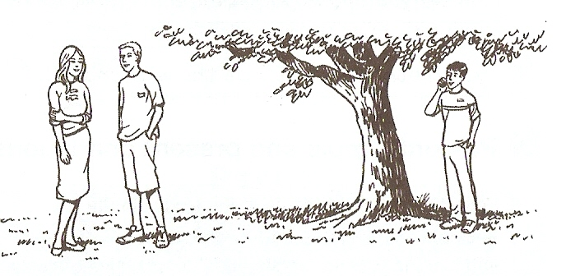There are two girls and a boy. I think they’re friends. The girl is sitting down and she’s wearing a skirt and a jacket. She’s talking to a boy with dark hair. He`s wearing shorts and a t-shirt. They both look serious. The other boy has dark hair too. He`s sitting under a tree and he`s writing something. He’s wearing shorts and a t-shirt.