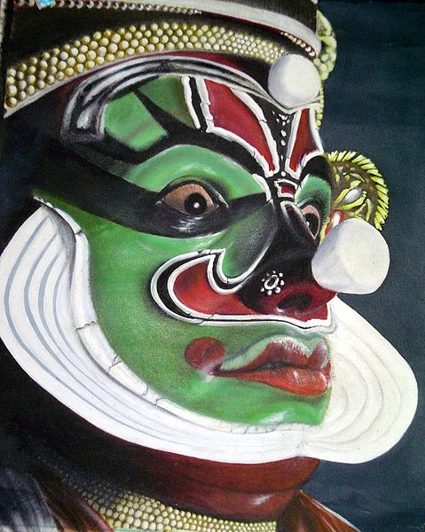
Body art

Body art is art made on, with, or consisting of, the human body. The most common forms of body art are tattoos and body piercings, but other types include scarification, branding, scalpelling, shaping (for example tight-lacing of corsets), full body tattoo and body painting.
More extreme body art can involve things such as mutilation or pushing the body to its physical limits. For example, one of Marina Abramovic's works involved dancing until she collapsed from exhaustion, while one of Dennis Oppenheim's better-known works saw him lying in the sunlight with a book on his chest, until his skin, excluding that covered by the book, was badly sunburned. It can even consist of the arrangement and dissection of preserved bodies in an artistic fashion, as in the case of the plastinated bodies used in the travelling Body Worlds exhibit.
Body art is also a sub-category of performance art, in which artists use or abuse their own body to make their particular statements.
In more recent times, body became a subject of much broader discussions and treatments that cannot be reduced to the body art in its common understanding. Important strategies that question the human body are: implants, body in symbiosis with the new technologies, virtual body etc. Scientific research in this area, for example that by Kevin Warwick, can be considered in this artistic vein[1]. A special case of the body art strategies is the absence of body. The most important artists that performed the "absence" of body through their artworks were: Keith Arnatt, Andy Warhol, Anthony Gormley and Davor Džalto.
(Taken from: http://www.all-art.org/art_20th_century/modern_art/BODY-ART1.htm)

Introduction to the History of Body Art

Body art has a long history. From the anthropologist’s perspective, decorating the human body dates back to the earliest times. Humans use art to communicate powerful messages. In late 2000, the American Museum of Natural History created an exhibition called “Body Art: Marks of Identity.” Dr. Enid Schildkrout described the modern practices of body art as “tattooing, piercing, body painting, body reshaping, henna, and scarification.” The virtual tour of a historical museum’s interpretation of body art provides one view of this diverse subject. Another view is from the post-Minimalist artists in the U.S. after Pop Art.
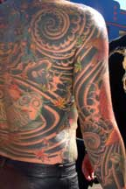
Throughout history, body art has captured the way that humans relate their experiences to their physical body. Examples of body art are recorded in many formats, including photographs, drawings, engravings, books, films, sculptures, and paintings. Schildkrout explains:
“Whether with permanent marks like tattoos or scars, or temporary decorations like makeup, clothing, and hairstyles, body art is a way of signalizing an individual’s place in society, marking a special moment, celebrating a transition in life or simply following a fashion.”
Tattoos, one of the most popular sample of body art, have an ancient history stretching back over thousands of years. Egyptians were tattooing themselves for decorative reasons back in the days of the pyramids. The Chinese adopted the form around 2,000 B.C. The body of a primitive man found frozen in the Swiss mountains dated to 2000 years ago had multiple tattoos on him. The practice of making permanent marks into the skin with pigment has been found at some point in nearly every major culture in history.
In some societies it helped identify bands of people - as when family crests or tribal symbols were used. During the Victorian era, the modern tattoo machine was first invented and patented, a design that has changed very little in style to this day. When explorers of that era came across primitive cultures that practiced tattooing, individuals were often returned to Europe for audiences and exhibitions. When religious missionaries encounter tattooing, they often do their best to discourage and end the practices. Sadly the twentieth century saw many native tattooing practices disappear, especially in the South Pacific island cultures.
Two decades after World War II ended, American artists were still reacting to Minimalism and other Modernist styles like Surrealism, Dadaism, and Cubism. The new body art of the late sixties and early seventies represented the artist’s feeling about the commercialization of art. Honour and Fleming (2005) note that artists debunked the concept of objects and places associated with the new art system; “they hoped to find a way of eluding the system – especially the system’s elaborate structures for endowing their work with an exclusiveness, rarity value and luxury character they did not want it to have.”
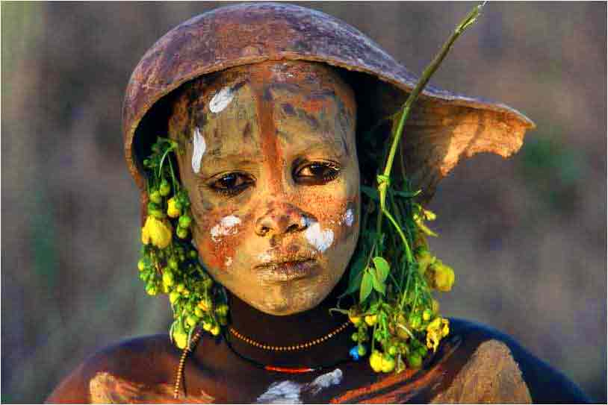
In other societies, criminals or outcasts were 'marked' in order that others would know clearly who they were. One of the most notorious uses of tattooing was in ancient China where the offender was marked with three lines on the forehead, forming the character for “dog” after the third offense. The Yakuza, a Japanese organized crime syndicate, historically has used full-body tattooing as a way of identifying members and/or proving commitment. Street gangs in contemporary America frequently utilize tattooing, often on the neck or hands to prove commitment, as the marks can’t be hidden casually and your group identity is always on view.
The word “tattoo” is fairly modern. The first recorded usage of the word is an entry in British sea Captain James Cook’s diary dated 1796. The word is derived from the Polynesian/Samoan root word “tatu,” a verb meaning “to strike.” There is also a related modern usage where a tattoo refers to a military exercise or a continuous drumming. Internet query searches quickly reveal there are a variety of common misspellings for the word “tattoos.” Popular errors are tatoos, tattos and tattoes.
The modern wave of tattoo interest has its roots in the late 1960s. For the first time, people with fine art training began to work in the field of skin art, bringing with them all their art history knowledge. The modern body art renaissance has been the saving grace for many tribal tattoo styles, now being worn by people with no attachment to the symbolic histories of many of these patterns. Nonetheless, this fascination with mixed cultural tattoo styles has saved certain styles of skin art from extinction.
For various tattoo histories, you might try some of the below titles.
In this period, body art was closely associated with performance art. In Europe, the use of human bodies as art forms emerged even before “Self-Portrait as a Fountain.” In 1960, Yves Klein (France), Lucio Fontana (Italy), and Gilbert and George (UK) created “living sculptures” with the assistance of live human models.
Whether you look to ancient history, Modernism, or twenty-first century art, you can find examples of adorning the human body or using the human body as a solid medium for artistic expression.
(Taken from: http://www.arthistory.net/artstyles/bodyart/bodyart1.html and http://www.bellaonline.com/articles/art11.asp)

