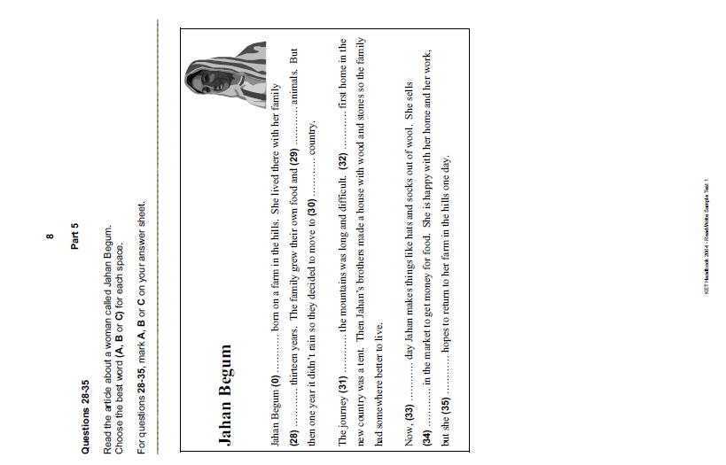
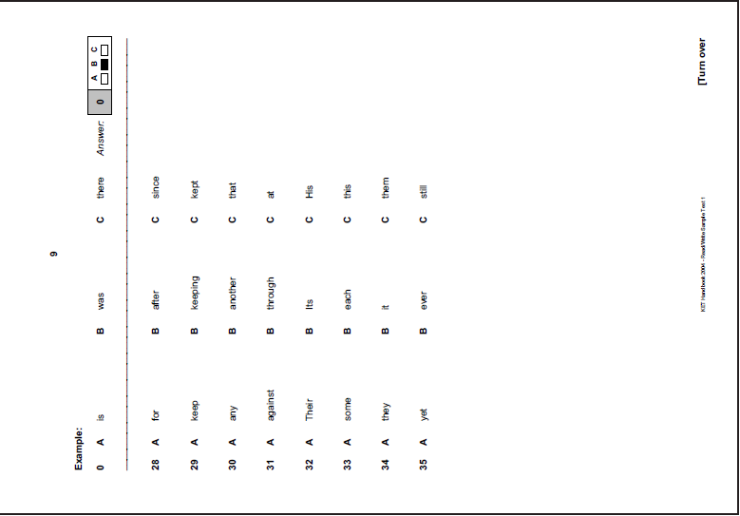
Questions 28-35. Read the article about penguins.
Choose the best word (A, B or C) for each space. For questions 28-35, mark A, B or C on your answer sheet.
PENGUINS
There (0) ………… seventeen different types of penguins. They can be (28) ………… forty centimetres to more than one metre tall. They all (29) ………… in the south part of the world. In winter, they swim (30) ………… long way to find warmer weather.
In spring, (31) ………… penguins come together on the beaches of Antarctica. The female penguin has one or two eggs. She puts (32) ………… eggs on the ground and sits there to keep (33) ………… warm. But she doesn’t sit all the time because penguins can move with one egg between their legs. (34) ………… the female penguin is sitting on the eggs, the male penguin brings her food. He also (35) ………… this when the baby penguins are born.
Example: 0 A is B are C be Answer:
28 A from B by C between
29 A lives B live C lived
30 A one B the C a
31 A lots B much C many
32 A her B hers C she
33 A it B them C their
34 A When B How C Who
35 A does B do C doing

